Shabbos Stories for
Parshas pinchas 5780
Volume 11, Issue 44 19 Tammuz / July 11, 2020
Printed L’illuy nishmas Nechama bas R’ Noach, a”h

For a free subscription, please forward your request to keren18@juno.com
Past stories can be found on the website ShabbosStories.com

The Empty Vessel
By Rabbi Sholom DovBer Avtzon

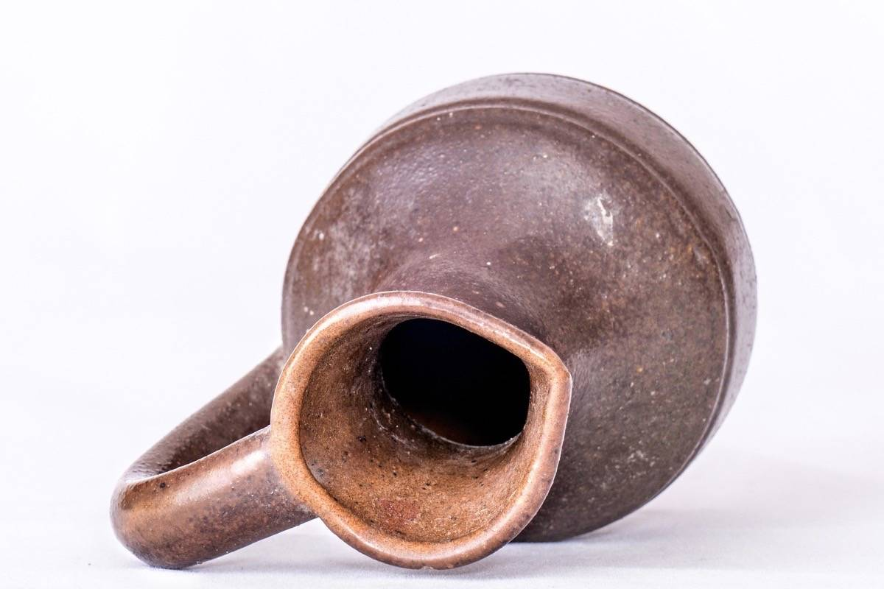

Reb Hillel Paritcher was instructed by the Mitteler Rebbe (Rabbi DovBer, 1773-1827) to travel to the colonies he established in the distant Ukraine. Every year, after Shavuos, Reb Hillel would leave Lubavitch on this three month journey and return to his hometown for Rosh Hashanah.
Reb Hillel’s visit to the various towns accomplished tremendously; chadorim were established and proper melamdim were hired. Shochtim, mohelim and sofrim were taught and encouraged to settle there, there was rejuvenation amongst hundreds and thousands of Jewish families.
One year, one of the people bemoaned to Reb Hillel and said, Rebbe, ever since I met you some years ago, I am trying to improve myself. I try to daven properly, I try to learn something more, but alas, I look at myself and see the truth, I am where I started, I was and empty vessel and remained an empty vessel. What was accomplished? NOTHING!!!
Reb Hillel gently replied, you accomplished great things, and I will prove it from your own words. Years ago, it didn’t bother you that you were what you now call an empty vessel, but now you are bemoaning that fact. Is that not a tremendous accomplishment?!

Reprinted from the Parshas Korach 5780 Weekly Story email of Rabbi Sholom DovBer Avtzon.

Who are You?

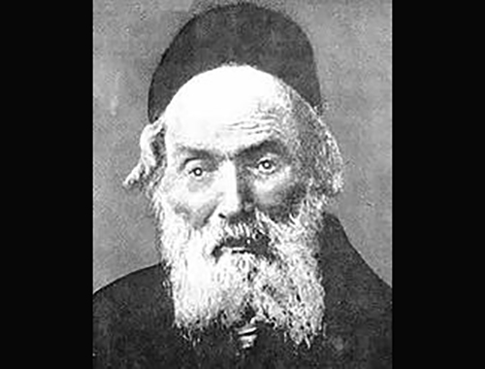

A guest introduced himself to the Chafetz Chaim, OB”M, as the grandson of a well-known Tzaddik (righteous person). The Chafetz Chaim was already hard of hearing at that time and he asked the younger man, “Who are you?” The man thought the elderly sage had not heard him, so he repeated that he was the grandson of a great Tzaddik.
The Chafetz Chaim raised his voice and asked again, “and who are you?” The man looked perplexed, so the Chafetz Chaim explained, “I heard who your grandfather is, but tell me, are you following in his ways? Are you deserving of such a grandfather?” (Story and Insight below from Power Points)
Comment: The Ohr Hachaim relates a parable about a person who was caught committing a crime and was arrested. He met with his lawyer who then asked him if he had any excuse for his actions. The man shook his head. “I really have no excuse, but should I mention that I am the son of the chief Rabbi?”
“Don’t you dare,” the lawyer warned him. “If you mention that, they will treat you much more severely.”

Reprinted from the Parshas Korach 5780 email of Torah Sweets Weekly.

Rebbe Nachum and
The Lost 400 Rubles
By Rabbi Tuvia Bolton

Almost two hundred years ago in the town of Chernobyl lived a great Tzadik (Holy gifted Jew) by the name of Rebbe Nachum who had hundreds even thousands of followers.
One afternoon a businessman (who we will call Reb. Zalman) entered the Chernobyl Synagogue followed by two gentiles carrying large boxes. He cleared two large tables, pushed them together, spread a large white tablecloth, announced a meal of thanksgiving and started taking out food drink and dishes from the boxes. Several bottles of good vodka, plates of fish, pickles, cakes, salads all for the miracle that their Rebbe just did for him.
The Chassidim stopped their learning, took their places around the table, poured themselves 'LeChaim' began eating and Reb Zalman began to tell his story.
"Fifteen years ago I came to market day here in Chernobyl to do business. I had four hundred rubles, a small fortune, in my pocket. I found a small hotel run by a religious Jew who gave me a room where I left my things (except for my money of course) and went to find a synagogue to pray the evening prayer and to begin making connections.
"I returned late that evening to find the second bed in the room occupied by another religious Jew who was soundly asleep with his face turned to the wall. I myself was so tired that I didn't give it much thought but went to bed and immediately fell into a deep slumber.

He Was Already Gone and I Noticed a Small Bag
"When I awoke a bit late the next morning he was already gone and so was his suitcase but as I was preparing to leave, I noticed a small bag under the foot of his bed near the wall. I picked it up and was surprised to see it contained four hundred rubles! No identification or anything, just a lot of money.
"I figured the fellow would probably come back and look for it so I put it under his pillow and went to the market locking the door behind me. But when I returned that night it was still there and for the next two days no one came to claim it.
"I should have given it to the hotel owner it but I figured he might keep it for himself and I tell him I found it because I didn't want him or anyone to know I was carrying so much money.
"Anyway, don't ask me why but suddenly it became obvious the money was mine. It was insane but I did it. I took the money and returned to the market for another day of bargaining as though it was the most natural thing in the world and afterward forgot the entire incident.

I Became Wealthy and Gave Huge Amounts of Money to Charity
Fifteen years passed. I became wealthy, gave huge amounts of charity, never forgot the needy or the Talmudic scholars and totally forgot the hotel room.
Until one night two weeks ago.
I was sound asleep when suddenly a dream. A ghost dressed in white with angry eyes put his face in mine and yelled. 'JUSTICE!! I want REVENGE!!!!!'
"I was paralyzed with fear. I had no idea who he was or what he was talking about, but before I could protest he said.
"'Of course you don't remember me! You never even saw me. But do you remember the four hundred rubles in the hotel room? Because of you, my family and I suffered for the last fifteen years!! When I returned home back then without that money the creditors began hounding me, everyone suspected me, no one trusted me. I couldn't get a loan and couldn't find work.
“I became depressed, had to sell my house. We were reduced to paupers begging for our meals. A few weeks ago I died a broken man. And after I died it was revealed to me in heaven! It was you!! You took the money!! You destroyed my life! I want JUSTICE!!!'
"He grabbed my hand to pull me out of the world and I woke in a cold sweat. It was a dream!! Only a dream!! But my hand hurt there were even bruises!"

He Threatened to Summon Me to the Heavenly Court
"The next day I went back to work and tried to forget the whole thing but I couldn't. And that next night he returned. And the night after! Threatening me and summoning me to the heavenly court! I was going crazy; afraid to even close my eyes every time I drowsed off there he was!!!"
"So I went the Holy Rabbi Aaron of Karlin. I reasoned that if anyone could help it would be him. I told him my story, he closed his eyes and was silent for several minutes. Then he took out pen and paper, wrote a letter, put it in an envelope and told me to take it to Rebbe Nachum of Chernobyl. He only one that can help
"Well, I did it. And when I finally got to Rebbe Nachum last week I was a wreck! Totally destroyed! I hadn't slept for weeks and felt more dead than alive.
"Rebbe Nachum looked at the letter, walked to the window stood there for a while and said. 'He has a strong case against you. A strong case. You should have tried harder to return the money. But, G-d willing, I think I can help.'
"When he said those words, I burst our crying like a baby until he held his hand up for me to stop. He continued. 'The next time he appears to you in a dream tell him that because the sin was done in this world the trial must be in this world and because he is summoning you, you can choose the venue. Tell him you want to be tried in my court. If he refuses come and tell me.'
"Well, that night the dead man appeared again and, to my surprise, when I gave him Rebbe Nachum's message he agreed.

Rebbe Nachum Told Me to Purify Myself
"The next morning I told the Rebbe and he told me to purify myself, pray for forgiveness, read Psalms. The trial will be in a few days.
"Two days later one of the Chassidim called me from my room and I went, shaking like a leaf, to the Rebbe. He put me in a small room with a large window, told me to wait and a few moments later he entered, went to the window, opened it and stood there silently looking outside for over an hour while I sat there weeping in fear for my life.
"Suddenly he said. 'The plaintiff says you robbed and killed him. He demands that you should die and that all your money should go to his family.
"But I told him I don't agree.
"'First of all, `I reminded him that there are many ways he could have lost his money. And, after all, you didn't steal it, it was he that lost it. That it was G-d's will that he lost the money but he himself who lost his mood. So, my decision is that you calculate the sum total of all your holdings. Right now!'
"He gave me a pad of paper and a pen and suddenly my mind became clear. 'Forty thousand rubles!' I announced. 'Very well' Said the Rebbe 'My decision Is that you must give half, twenty thousand rubles, to this man's widow and orphans.'
"The Rebbe then looked out the window in silence for another ten minutes and again spoke: 'The plaintiff protests. He claims that money is not enough. He wants you to suffer for the shame and suffering that you caused him.'
"'But' said the Rebbe, 'I disagree. You can only be judged as you are now and presently you are a crushed man that completely regrets his sin with a totally broken heart and that is sufficient. So my final decision stands!! You must give his family half your wealth and he must leave you alone.'
"That," Concluded Reb Zalman "Was a week ago. The next day I gave his widow the money and since then he has stopped appearing.
That is why I'm making this thanksgiving meal. Your Rebbe saved me!! LeChaim!!!"

Reprinted from the Parshat Korach 5780 email of Yeshiva Ohr Tmimim in Kfar Chabad, Israel. Adapted from a story (HaChozrim B'Tshuva by Yisroel Klapholtz pg. 238)
A Legacy of a Building
For the Navardik Yeshiva

THE ALTER OF NAVARDIK was told about an individual who wrote in his will that he wanted to donate an entire building to the Yeshiva of Navardik. The Alter traveled to Germany just for the purpose of acquiring the building for his Yeshiva.
However, on the way, the Alter found out that another Yeshiva was traveling there as well because they wanted the building. The Alter contemplated and came to the immediate conclusion that it may turn into some form of machlokes. Straightaway, the Alter made an about face and headed directly back toward the direction he was coming from. The Alter would not even think of first going there at least to get some clarification to the situation. He decided then and there never to think about the inyan ever again since there was the thought that it could lead to machlokes. This is what it means to be a מהמחלוקת רודף.
Reprinted from the Chukas 5780 email of Eitz Chaim in Eretz Yisroel
The Messy House

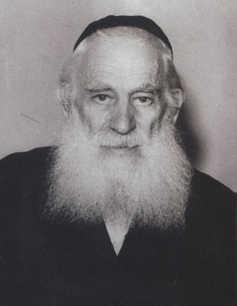
Rabbi Yosef Shlomo Kahaneman

A YUNGERMAN CAME TO the Ponivicher Rov (Rabbi Yosef Shlomo Kahaneman, zt”l) begging him to help him give a get to his wife. He claimed their house was always a huge mess. It was a disaster and his wife just didn’t know how to keep on top of the cleaning.
The Ponivicher Rov told him, “I hear. I can help you with the details. Just please come to my house tomorrow at nine o’clock to discuss things.”
The Rov came home that night and told his Rebbitzin (who was meticulous about keeping the house clean and neat), “We need to mess up our house.”
They “literally” turned the house upside down! When the yungerman came the next morning there was laundry on the floor, leftovers on the table, the sinks were piled with loads of dishes and there were toys scattered in the entrance way to the house (as you could imagine).
The Ponivicher Rov turned to the yungerman and said, “Okay, let’s continue our discussion.”
The yungerman surveyed his surroundings. He thought to himself, “Even the Ponivicher Rov’s house is like that!” He turned to the Rov and said, “It’s okay, I don’t need anything anymore.

Reprinted from the Chukas 5780 email of Eitz Chaim in Eretz Yisroel.
A Lesson Can Be Learned From:
The Time for Shabbat
Candle Lighting is…

From the mid-1990’s until June, 1999, a ticker appeared at the bottom of the front page of the New York Times every Friday, stating: “Jewish women: Shabbat candle lighting time is ____”.
This ticker cost almost $2,000 each week and was financed by a wealthy philanthropist. The production manager of the Times, an Irish Catholic, made it a personal priority to find out the lighting time each week. After June, 1999, the ticker stopped, but it reappeared again once.
On January 1, 2000, the Times printed a special 3-page issue, with the news of January 1, 1900, the news of January 1, 2000, and fictional “news” of January 1, 2100.
On that third page, the ticker appeared. The production manager said “We don’t know what the news will be in the year 2100. But you can be certain that in 2100, Jewish women will be lighting Shabbos candles”.

Reprinted from the Parshas Korach 5780 email of the Pleasant Ridge Newsletter.

Appealing to the Healer
Of all Flesh Himself

My wife had a pounding headache that was getting more intense. Every doctor examination was a waste. After in-depth examinations, it was decided that it must be a psychiatric problem and we had to make an appointment with a psychiatrist. The headaches were caused by an imagination run wild.
It broke my heart to hear this as my wife suffered such pain. I have a strong connection with the Creator of the world. I took some money and set it aside for Tzedakah. I raised my eyes to Heaven and asked from the depth of my heart to send a cure from the Healer of all flesh Himself and bring relief to my aishes chayil who was suffering so much!!!
I cried an outpouring of tears and I asked for help from Hashem and with the Tzedakah money, Hashem should hire a private doctor for me. The next day I received a referral for my wife at the hospital. This was not easy as I went from doctor to doctor, and I had to work and take care of the family.
We got to the hospital and they took my wife from the examining room for a CT scan of her head. The CT showed a growth that was causing all the pain, and no one thought of checking except for the private doctor that I had hired by giving Tzedakah and my tears.
From the CT scan, they took my wife to the operating room where there was a specialist, and everything worked out well and my wife made a full recovery from Yisbarach!!! With thanks to the Healer of all flesh for all His kindnesses. ה

Reprinted from the Parshas Korach 5780 email of Tiv Hakehillah.

Rabbi Yonasan Eibeschutz’s Yom Kippur Experience
By R’ Mendel Berlin

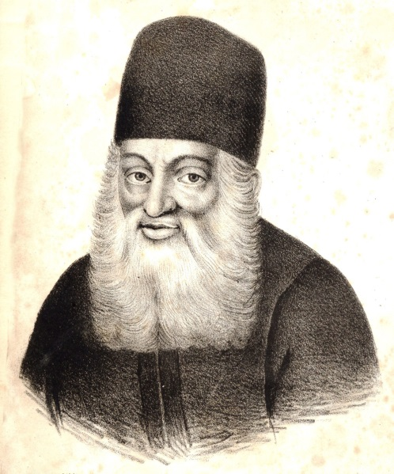
Rabbi Yonasan Eibeschutz zt’’l, one of Jewry’s most influential leaders during the early 1700s, was away from his home for one Yom Kippur and was forced to spend that holy day in a small town. Without revealing his identity as Chief Rabbi of Prague he entered a synagogue and surveyed the room, looking for a suitable place to pray.
His eyes fell upon a man who was swaying fervently, tears swelling in his eyes.
“How encouraging,” thought the Rabbi, “I will sit next to him. His prayers will surely inspire me.”
The man cried softly as he prayed, and tears flowed down his face. “I am but dust in my life, Oh Hashem,” wept the man. Reb Yonasan was truly inspired. During the congregation’s reading of the Torah, a man from the front of the synagogue was called for the third aliyah, one of the most honourable for a Yisroel, and suddenly Rabbi Eibeschutz’s neighbour charged the bima!
“Him!” shouted the man. “You give this aliyah to HIM?” The shul went silent. “I know how to learn three times as much as he! I give more charity than he and I have a more illustrious family! And he gets this honour? What a travesty!!!” With that the man stormed back toward his seat.
Rabbi Eibeschutz could not believe what he saw. “I don’t understand,” he began. “Minutes ago, you were crying about how insignificant and unworthy you are and now you are clamouring to get that man’s aliyah?”
Disgusted, the man snapped back. “What are you talking about? Compared to Hashem I am truly a nothing.” Then he pointed to the bima and sneered, “But not compared to this guy!”

Reprinted from the Parshat Emor 5780 email of Oneg Shabbos (London, U.K.) Originally printed in Torah Sweets Weekly.

The Mesiras Nefesh Challenge Of the Steipler Gaon
By Jack E. Rahmey

The following story of mesirus nefesh, as told by Rabbi Shlomo Brevda, shows the sacrifices made by our Gedolim and the previous generations. The high price that they had to pay in order to keep Shabbos should be an inspiration for us, as we realize the wonderful gift that we have today of being able to keep the Shabbos properly and without suffering.
The Steipler Gaon, Harav Yaakov Kanievsky zt’’l, was a gaon and a tzaddik. His brilliance and encyclopaedic knowledge of Torah was only overshadowed by his righteousness and total devotion to serving Hashem.
Prior to his engagement to the sister of the Chazon Ish, he shared an incident with her that happened to him in Siberia. He felt it was important that his intended be fully aware of his mesirus nefesh for mitzvos. As a solider conscripted into the Czar’s army, the Steipler was forced to perform back-breaking labour in the frigid cold of the Siberian winter.

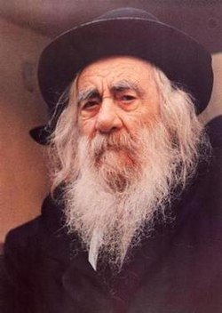
The Steipler Gaon, zt”l

Regardless of the overwhelming toil and below-freezing conditions, he performed the difficult work because he knew it was the only way that he could continue to serve the Al-mighty. The problem was that army demanded that everyone work seven days a week. This obviously created a problem on Shabbos. The Steipler emphatically declared that by no means was he going to work on Shabbos. The Russian officer did not tolerate even one insolent Jew who had the gall to refuse his orders. He predictably flew into a rage, typical of the anti-Semitic brute that he was.
Suddenly, he stopped screaming, as a diabolical smile crossed his face. Yes, he would grant the Steipler’s request on the condition that he pass a little test. If he could prove himself to be a strong warrior, he would be permitted to observe Shabbos. The test was “simple.”
The captain ordered his soldiers to form two rows opposite each other, arming themselves with wooden planks. The Steipler was to “attempt” to make it from one end of the row to the other as the soldiers beat him mercilessly with their planks. If he survived the ordeal, he would be allowed to observe Shabbos.
The Steipler understood the situation. He was probably risking his life, but Shabbos was worth the ordeal. He put his hands over his head as protection, whispered a heartfelt prayer and forged ahead. The guards began to beat him with all they had: no mercy, no sensitivity, just pure brutal malevolence. The pain was intolerable, but the reward of keeping Shabbos was the pot of gold at the end. Inch by inch, he trudged forward, blinded by pain and covered with blood. He reached the end of the line and collapsed……… with a faint smile on his lips.

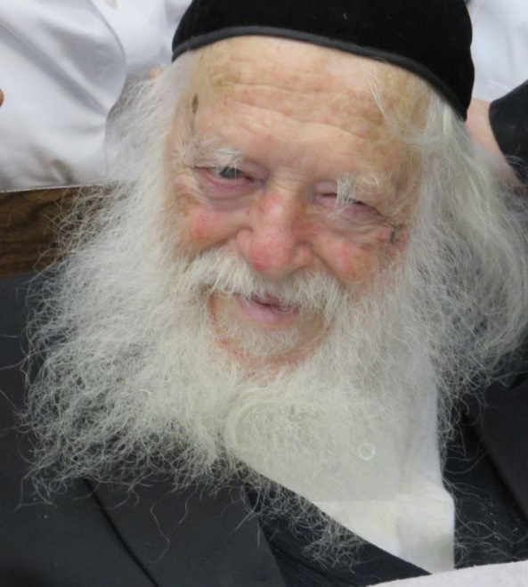
Rabbi Chaim Kanievski, shlita

He had made it! The Shabbos that he cared about so much must have surely protected him. The captain reluctantly gave in to the Steipler’s demand to observe Shabbos. The Steipler lay on the ground, bloodied and broken. Nobody bothered to pick him up, but he did not care. He had triumphed over the cruel officer. He had triumphed over the yetzer hara, the evil inclination. He had won Shabbos Kodesh! The Steipler concluded the story, looked at his intended kallah and asked, “Are you prepared to join me in a continuous quest of self-sacrifice for Torah and mitzvos? This is the life I plan to lead.”
The future Rebbetzin, the mother of today’s pre-eminent gaon Harav Chaim Kanievsky shlit”a, replied in the affirmative and they became chosson and kallah. There’s a famous saying that goes “As much as the Jews kept Shabbos, the Shabbos kept the Jews!” The Shabbos that we keep today and that we kept throughout the generations is the secret that has kept the Jewish people alive as a great nation until this very day.

Reprinted from the Parshat Emor 5780 email of Oneg Shabbos (London, UK). Originally printed in the Vayakhel 5779 email of Rabbi Amram Sananes as written by Jack E. Rahmey.

Thank You Doctor
By Rabbi Menachem Salasnik

In his book, Reflections of the Maggid, Rabbi Paysach Krohn tells the following fabulous story:

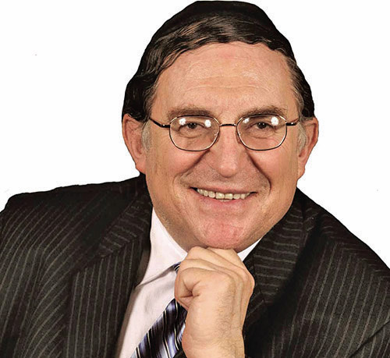
Rabbi Paysach Krohn

‘As Senior Resident in Brigham and Women’s Hospital in Boston, Dr. Lebowitz was in charge of its often frenzied emergency room. One afternoon as he was making his rounds, the loudspeaker blared a “Code Blue” alert, the words that indicate an emergency life-threatening situation.
A woman had suffered a severe heart attack in the cafeteria upstairs and was in cardiac arrest. Dr. Lebowitz grabbed his equipment and raced upstairs, where he found doctors already working on the woman. All patrons had been cleared from the cafeteria, as a hospital security officer stood guard at the door, not allowing anyone in except medical personnel.
Dr. Lebowitz rushed toward the huddle of people in the middle of the room. “How is she doing?” he asked one of the doctors, who was kneeling on the floor attending the stricken woman.
“I’m afraid it’s too late,” the doctor replied. “We’ve been working on her for a while already.”
“Let me try,” Dr. Lebowitz said, quickly moving toward the patient. He inserted an intravenous catheter directly into her heart to get her started on epinephrine, which would prevent further progression of the blood clot to her coronary arteries. He applied two large paddles known as defibrillators to her body, so that he could send an electric shock to the heart to jumpstart it back into a normal rhythm. Dr. Lebowitz tried numerous times to get a heartbeat, but he was unsuccessful.
The other doctors began to leave the cafeteria, shaking their heads in disappointment that a patient had died right before their eyes.
However, Dr. Lebowitz would not give up … not yet. He tried a fifth and sixth time to stimulate a heartbeat, but it wasn’t happening. He realized that the end was near, if it had not already come. He would try one more time. He pressed the control button on the defibrillator with added emphasis. He glanced at the cardiac monitor. The razorthin line that had been flat darted upwards! There was life!
A doctor called out in disbelief, “You’ve got a heartbeat!”
Infused with hope and determination, Dr. Lebowitz worked frantically to continue the heart’s revival and with concerted effort, he managed to stimulate a feeble pulse. He ordered the medics to transfer the patient to the third floor intensive care unit, where she would be treated and observed every moment. Once in the ICU, her progress was slow but steady.
Dr Lebowitz returned to the emergency room to continue his full-time duties. Periodically he would call up to the ICU unit to get the latest update on the woman’s condition. Six hours later he was told the good news that she was being allowed to sit up in bed. He decided that he would visit her. As he walked to her room he wondered how to introduce himself. When he entered the room he didn’t have to say a word.
A man sitting next to her called out, “He’s the one! He’s the one who saved your life! That’s the one I’ve been telling you about.”
“And who are you?” Dr. Lebowitz said, extending his hand to the gentleman.
“I’m her husband and I saw how you worked to save my wife’s life.” “Where were you?” Dr. Lebowitz asked. “I was with her when it happened, but then they whisked me out of the room and I stood watching from behind the glass wall.”
The woman began crying uncontrollably. Dr. Lebowitz stood there somewhat embarrassed, waiting for her to compose herself. When she did, she spoke softly and said words Dr. Lebowitz will never forget.
“What do I say? Thank you? That’s what you say to someone who holds a door open for you, not to someone who has just given you back your life. But I will tell you this. When I go home and see my children I will remember you and say, ‘Thank you Dr. Lebowitz.’
“In a week from now when I take a walk with my husband I will think of you and say, ‘Thank you Dr. Lebowitz.’ The next time I go out with my friends I will think of you and say, ‘Thank you Dr. Lebowitz.’ And the next time I have a birthday, I will remember you and say, ‘Thank you Dr. Lebowitz.’”
Her words were simple but heartfelt, gentle but powerful. When Dr. Lebowitz left the room he walked out into the hospital corridor and said to no one and to anyone,
“When I go home and see my wife and family, I’m going to say, ‘Thank you, Hashem,’ and the next time I pray and feel connected to Hashem I will remember and say, ‘Thank you Rabbi [Noach] Weinberg,’ (who had been integral to his religious growth) and the next time I learn Chumash I will say, ‘Thank you Rabbi Weinberg.’ The next time I walk up the stairs and don’t get out of breath I will say, ‘Thank you Hashem.’
Dr. Lebowitz returned to the emergency room a humbled and grateful person.’ We have been given the unparalleled gift of life, where every heartbeat, every breath, every movement and sense is a miracle. How is it possible to truly say thank you for our life? How can those two words do any justice in expressing the gratitude that we should be feeling?
The only way is to learn from this patient – in every aspect of our lives, whether it is spending time with our family, enjoying ourselves on holiday, going to work, or just resting, we should be thinking : thank you Hashem for giving me the ability to experience this moment! For something that is as big as life itself, “thank you” cannot be just a casual, throwaway statement; it needs to be truly lived!

Reprinted from the Parshas Emor 5780 email of Oneg Shabbos (London, UK)

